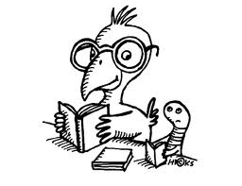
Running Record Assessment Form
Error Rate | Percentage Accuracy
1:100 | 99%
1:50 | 98%
1:35 | 97%
1:25 | 96%
1:20 | 95%
1:17 | 94%
1:14 | 93%
1:12.5 | 92%
1:11.75 | 91%
1:10 | 90%

Date ____________________
Student _____________________
Recorder _____________________

Reading Level:
Accuracy Rate: running words ____________ = 1: ____ = _____%
Errors
Self Correction Rate: Errors + SC = _________ = 1: ____
SC
Easy Text  (96-100 %) | Appropriate Instructional Text  (93-95%) | Challenging Instructional Text  (90-92%) | Hard Text  (Below 90%)
Move child to a higher text level | A comfortable instructional text level. | Child may require more direct support. | Move child to lower level.

Self-Correction Rate | 1:1 – 1:3  Excellent | 1:4 – 1:5  Good | 0 or over 1:5  needs improvement

Page # | Title of Book or passage  ______________________________________________________ | E | SC | Errors  MSV | SC  MSV
Analyze each error. Draw circle around the miscue the student uses:
M if the student was trying to use meaning M S V
S if the student was trying to use language structure M S V
V if the student was trying to use visual cues M S V
Page # | Title of Book or passage  ______________________________________________________ | E | SC | Errors  MSV | SC  MSV
Analyze each error. Draw circle around the miscue the student uses:
M if the student was trying to use meaning M S V
S if the student was trying to use language structure M S V
V if the student was trying to use visual cues M S V
Analysis of retelling: (Main idea, characters, setting, vocabulary)
Analyze each error. Draw circle around the miscue the student uses:
M if the student was trying to use meaning M S V
S if the student was trying to use language structure M S V
V if the student was trying to use visual cues M S V

